**Formula Sheet: Probability and Stats**

1. t-tests: (a) $\frac{\overline{x}-µ}{s/\sqrt{n}}$ (b) t = $\frac{{\overline{X}}_{1}-{\overline{X}}_{2}-μ_{1}-μ_{2}}{\sqrt{\frac{\left(n_{1}-1\right)s_{1}^{2}+\left(n_{2}-1\right)s_{2}^{2}}{n_{1}+n_{2}-2 }\sqrt{\frac{1}{n_{1}}+\frac{1}{n_{2}}}}}$
2. Coefficient of correlation = r = $\frac{n\sum{YX- \sum{Y}}\sum{X}}{\sqrt{n\sum{X^{2}- ({\sum{X})}^{2}}}\sqrt{n\sum{Y^{2}- ({\sum{Y})}^{2}}}}$
${SS}_{T}=\sum{\sum{y_{ij}^{2}-\frac{y_{..}^{2}}{N}}} and {SS}_{treatments }=\sum{\frac{y_{i.}^{2}}{n}-\frac{y_{..}^{2}}{N}}$

3. Test of linearity for regression coefficient: $t=\frac{b_{1}}{s/\sqrt{S_{xx}}}$

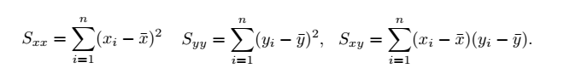

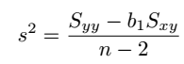

Determining Regression Equation

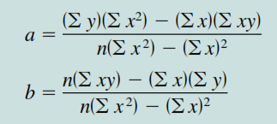

Hypothesis testing for Correlation : 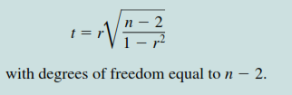

Simple Linear Regression Model: 

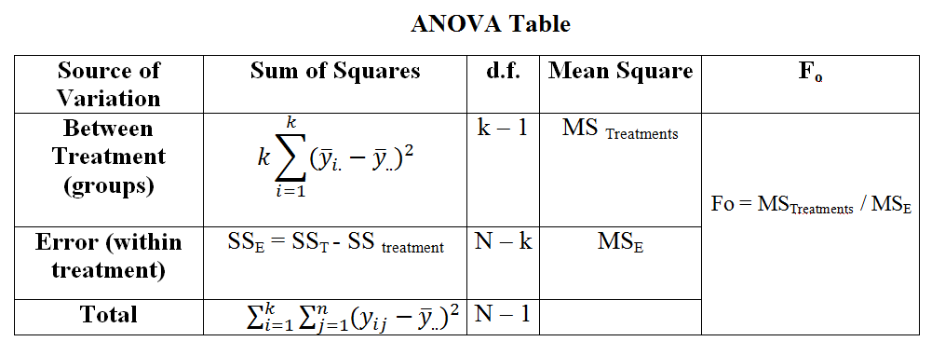

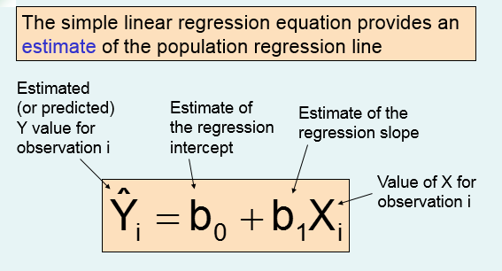

**ANOVA :**

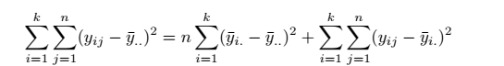



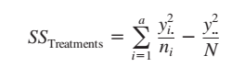

**Multiple regression Model:**

**Y = α + β1X1 + β2X2 + ε**

**Normal Equation:**

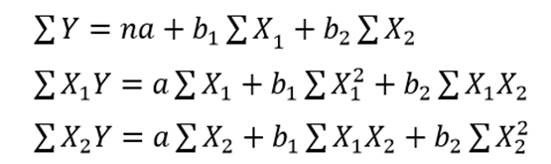

**t-test: (a) $\frac{\overline{x}-µ}{s/\sqrt{n}}$, t = $\frac{{\overline{X}}_{1}-{\overline{X}}_{2}-μ_{1}-μ_{2}}{\sqrt{\frac{\left(n_{1}-1\right)s_{1}^{2}+\left(n_{2}-1\right)s_{2}^{2}}{n_{1}+n_{2}-2 }\sqrt{\frac{1}{n_{1}}+\frac{1}{n_{2}}}}}$ t = $\frac{{\overline{X}}_{1}-{\overline{X}}_{2}-μ_{1}-μ_{2}}{\sqrt{\frac{s_{1}^{2}}{n_{1}}+\frac{s_{2}^{2}}{n_{2}}}}$**

**Coefficient of correlation= r = $\frac{n\sum{YX- \sum{Y}}\sum{X}}{\sqrt{n\sum{X^{2}- ({\sum{X})}^{2}}}\sqrt{n\sum{Y^{2}- ({\sum{Y})}^{2}}}}$**

**Multiple correlation coefficient: R = $\sqrt{\frac{r_{{yx}_{1}}^{2}+r_{{yx}_{2}}^{2}-2r_{{yx}_{1}}.r_{{yx}_{2}}.r_{x_{1}x_{2}}}{1-r_{x_{1}x_{2}}^{2}}}$**

**Standard error = $\sqrt{\frac{{\sum{(y-y^{'})}}^{2}}{n-2}}$, pooled Variance :** 



**Related Populations The Paired Difference Test : Di = X1i - X2i** , 



**Hypothesis tests for µ1 - µ2 with σ1 and σ2 unknown and not assumed equal:**



**Or Take : V = n-2 , with the least data value (Rule of thumb) see problem in book or ppts.**

**Note : Students this formula sheet is prepared from PPts however some formulas are missing while you practice problem Remember them.**

**Only selected formulas will be provided in Final Exam Papers , so make sure you have remember some Formulas.**